Robert Kristian Alm
Movant 19/03/2017

6d (VLANs and Trunks for Beginners - Part 4)

Link to the video: https://www.youtube.com/watch?v=8WHr0pLbTKs

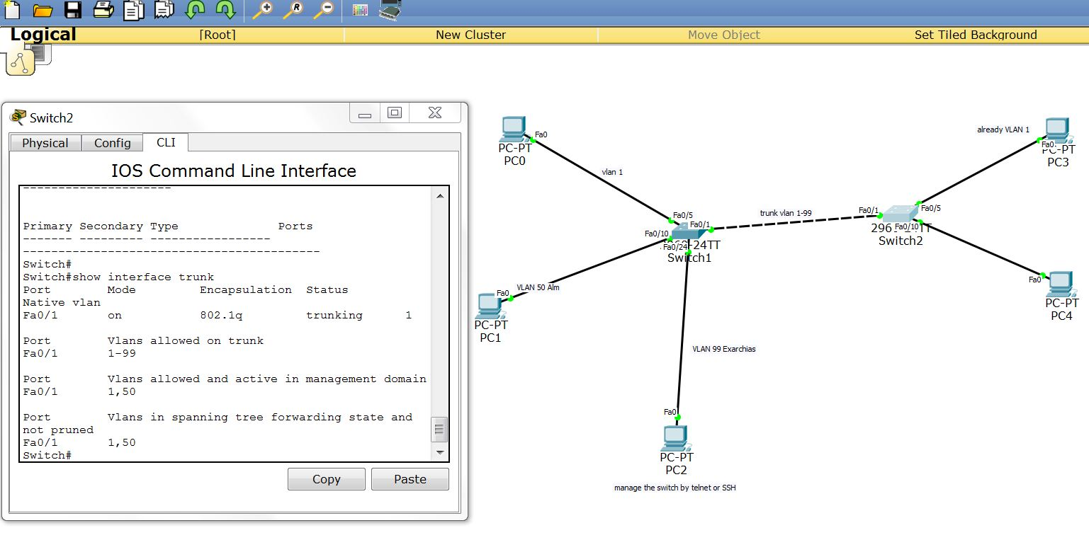

On this part of the assignment we worked actually with the trunk mode. We activated trunk mode on both Switches and we tested that everything is working as it should. No hardware was added.
On the end of the presentation, we checked the path and consistence of a simple DPU through simulation mode.

In order to activate the trunk mode we had to do it both switches through CLI. there is an option to make it to transfer the trunk mode automatically to switch2 but we did this manuals for reasons of control. On switch 1 we had to give a password in order to access it because it has secret enabled:

conf t
int fa0/1
switchport mode trunk
switchport trunk allowed vlan 1-99

It was exactly the same process in both switches. One more addition to the knowledge was the how to of show things, and actually we checked the trunk interface through the command:

show interface trunk

The last part of the video was theory and checking details through simulation mode. But to transfer the theory on my documentation will make my documentation complex and unreadable, (and I will get probably too far away from the assignment), so I will avoid to get to details.

